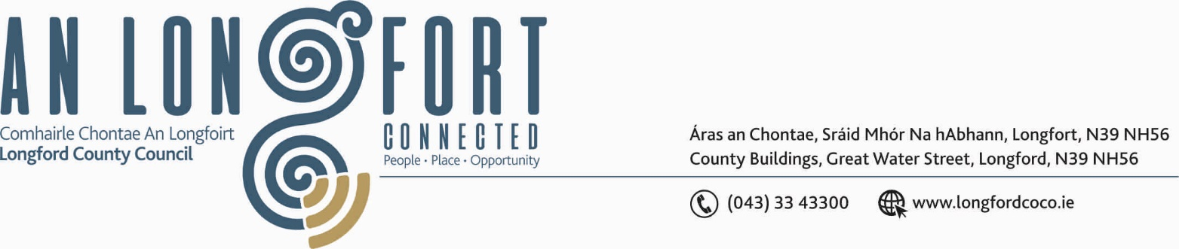

LONNGFORD MUNICIPAL DISTRICT

Please note meeting will be held in Longford Rugby Club and via Microsoft Teams.

17th June 2021

To: Each Member of Longford Municipal District.

A Chomhairleoir,

You are requested to attend the Annual Meeting of Longford Municipal District to be held in Longford Rugby Club, Demesne, Longford on Wednesday, 23rd June 2021 at 4.00 p.m.to transact business, as set out on the Agenda hereunder.

Mise le meas,

Ann Marie Mc Keon
_______________
Ann Marie Mc Keon,
Meetings Administrator.

C L A R

1. Election of Cathaoirleach.

2. Election of Leas Cathaoirleach.

3. Fix date and time of Longford Municipal District meetings.



